# Experiment 10: Mini Project

**Aim:** To create a mini project depicting the use of SQL in a software for Computer Sales Management

This is a mini project based on a Computer Sales Management System

The objective here is to create a software to record and store a purchase order in the form of a bill

The application created in VB, contains 3 end pages, 1 main menu and 1 splash page

**Working:**

The Display Stock Info button on the main page loads the Stock_info page that contains the data of all the components being sold in the store. Details include the price, id, name, in stock number, etc depending on the component

The Sale_log page shows info of all the transactions that have been successfully completed in the past. This page contains info of all the purchases completed, the ID’s of the items purchased, the total_cost paid and other such info

The Billing_page is the most interesting page, whose source code contains the SQL commands to actually insert data into the tables regarding the current purchase, whose bill is being made

Actions:

1. Insert data regarding the customer into the bill table
2. Insert the ID’s of the items being purchased and their quantities
3. Update the respective component table by reducing stock by the quantity specified at the Billing page
4. Update the Sale_log

**Screenshots:**

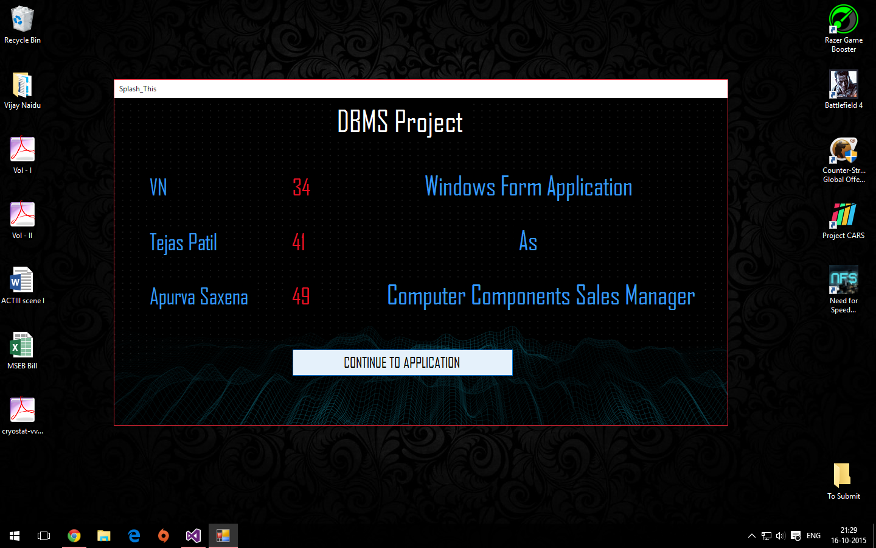

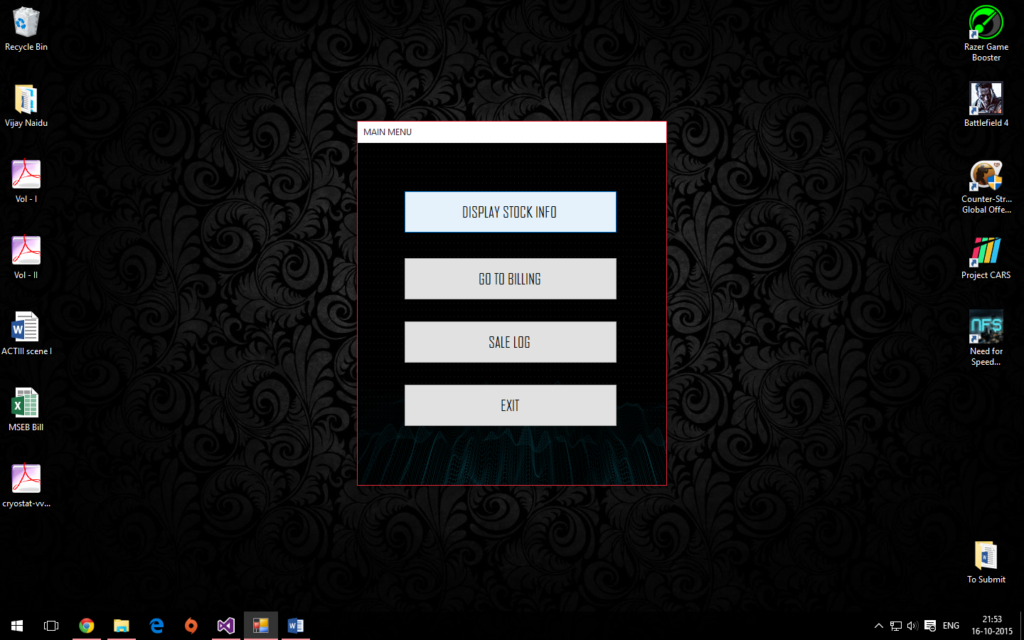

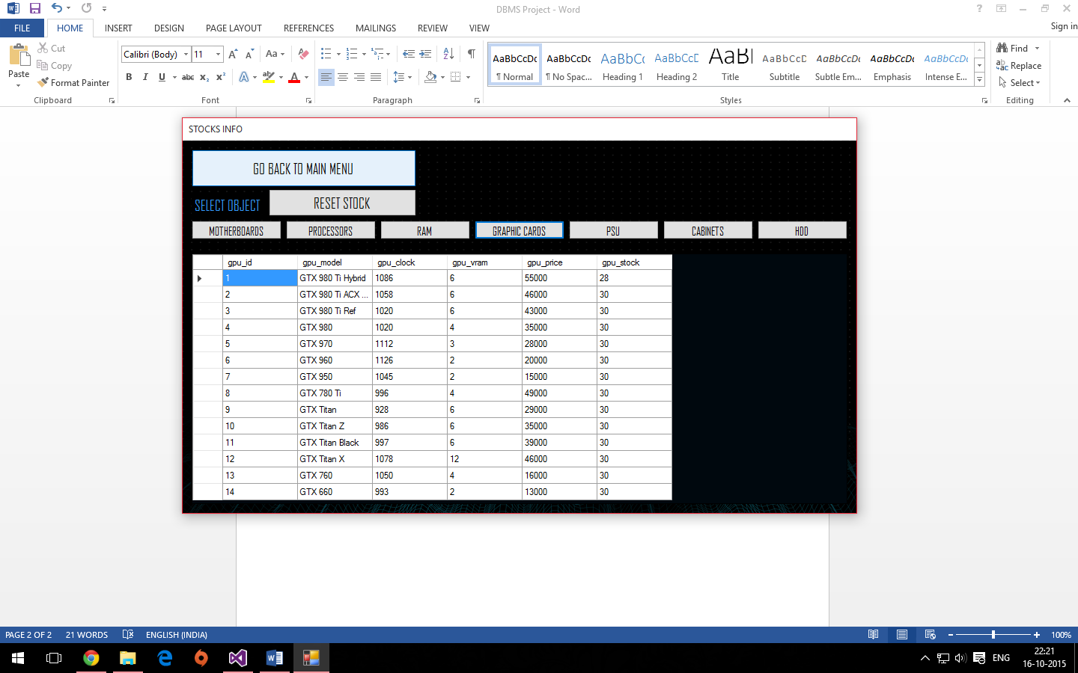

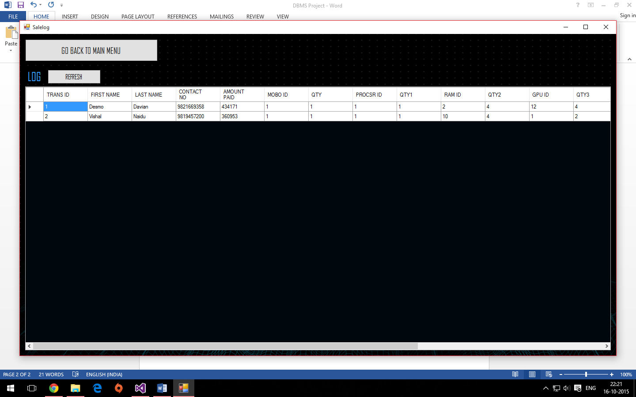

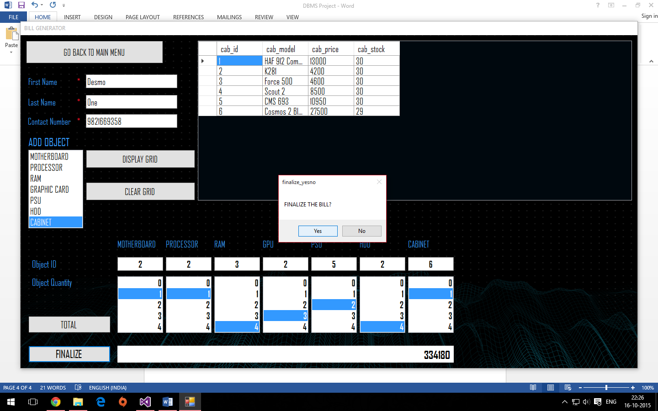

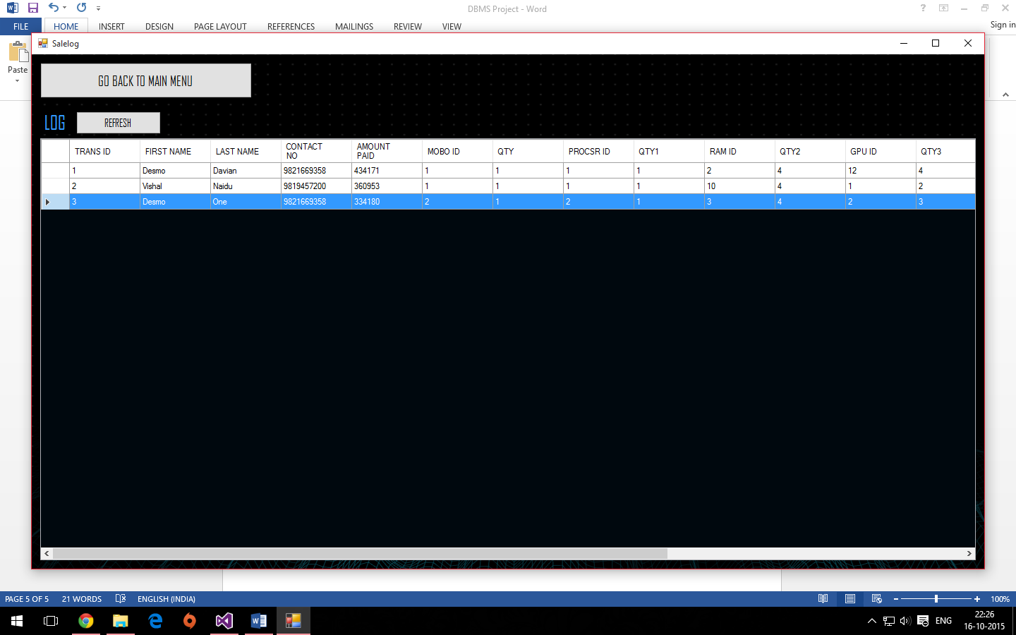

**Conclusion:**

Hence, we have learned how to use SQL and VB side by side to create useful applications backed up by a Database Management System

**Note:**

1. Couldn’t add more screenshots due to file size restriction in *moodle.spit.ac.in*
2. Zoom in to view the images more clearer